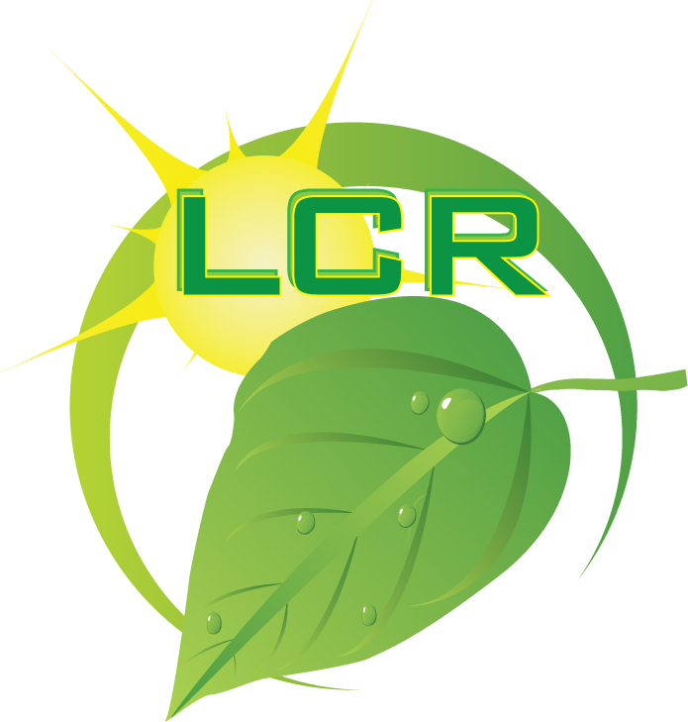 | Larson Century Ranch, Inc.  P.O. Box 1982, Clarkston WA 99403  Phone: 509-758-5445, FAX: 509-758-5701  E-Mail: Sales@LarsonCenturyRanch.com  Site: www.LarsonCenturyRanch.com
LCR EcoMiracle AgWash
Formula's & Technology
LCR EcoMiracle AgWash
FORMULA'S
((Non-Toxic))

These Formulas are made using the amazing colloidal miscelle chemistry (also known as a nanotechnology). These non-toxic, all natural ingredient formulas can be used for soaps, cleaning and polishing products, personal care products, household products, pet products, industrial products, and natural surfactants.

This same technology has been used in such great products as the GEO line of products by GEO International, Clear Choice™ and Total Solutions™ by Planet Solutions, Botanic GOLD™ by PureTec International, Tidy Up™ by Heartland Products, Life Time Solutions™ by 1st Enviro and All Purpose Solution™ by Solutions4you.

The Big YES's ...

LCR EcoMiracle AgWash Formulas basic formulas are all natural, baby safe, biodegradable, effective (95% more effective than their toxic counterpart), extremely soluble, hypoallergenic, non-toxic, water based, and can be used safely in confined areas.

LCR EcoMiracle AgWash formulas are proprietary, bio-based soap formulas consisting of fatty acids, vegetable- and plant-based enzymes and minerals, organic alcohol, coconut oil, folic acid, and natural vanilla, mixed with de-ionized water. All of LCR EcoMiracle Wash ingredients are found on the Food and Drug Administration’s (FDA) GRAS (“Generally Recognized as Safe”) List.

LCR EcoMiracle AgWash "GREEN" products and formulas can be used indoors without fear of compromising air quality. They can be used outdoors on plants, lawns and pavements of all types without endangering the environment and, in many cases, actually enhancing it.

The Big NO's ...

Our basic formulas contain NO ammonia, ammonium hydroxide, animal products, artificial ingredients, bleach, chlorine, citric acid, dyes or colors, formaldehyde, hydrochloric acid, isopropyl alcohol, lye, naphtha, nitrobenzene, perchlorethylene, perfumes or fragrances, phenols, phosphates, propylene glycol, sodium hypochlorite, sodium laurel sulfate, synthetic chemicals, thickeners, or trichloroethane.

LCR EcoMiracle AgWash Formulas are pure soap. NO WARNING LABEL OF ANY KIND is required to be placed on LCR EcoMiracle Wash products by any Federal, state or municipal agencies.

LCR EcoMiracle AgWash formulas are non-abrasive, non-caustic, non-combustible, non-corrosive, non-explosive, non-flammable, non-fuming, non-hazardous, non-polluting, and non-toxic.

We sell basic concentrates for general use or we can design a formula especially for your specific needs. Already formulated concentrates are available by the gallon, drum, or tanker load.

Larson Century Ranch, Inc.
P.O. Box 1982, Clarkston WA 99403
Phone: 509-758-5445, FAX: 509-758-5701
E-Mail: Sales@LarsonCenturyRanch.com
Site: www.LarsonCenturyRanch.com
LCR EcoMiracle AgWash
TECHNOLOGY

Behind our products is one of this century's most promising advances in environmental science, colloidal chemistry. LCR EcoMiracle AgWash provides a new solution to the personal health and environmental hazards of toxic cleaners and the free radicals emitted by them.

Colloidal products are non-hazardous, non-fuming, non-caustic, non-corrosive, non-combustible, non-explosive, non-hazardous. While highly effective, they are exceptionally gentle, safer and readily biodegradable.

They are phenomenally effective in preventing further environmental contamination. The price is only slightly more than harsh chemical cleaners and solvents, offset by reductions in Workman's Compensation claims, cost of protective clothing, expensive disposal procedures and fire insurance.

One container of colloidal concentrate can replace dozens of hazardous chemical cleaners and solvents, including household, industrial, marine, agricultural, vehicle and boat maintenance, and pet care chemicals.

The precise ingredients and blending process are proprietary. The ingredients conform to, and are defined as non-hazardous under OSHA Standards 29 CFR-1910 1200 and all of them are on the Food and Drug Administration's (FDA) GRAS (generally recognized as safe) List.

A representation of micelles in soap. Organic matter is suspended inside the micelle.

What is colloidal micelle?
The heart of this new chemistry is the technology used to develop a "colloidal micelle." Sub-microscopic particles are created in a microscopic field similar to a magnetic field. It differs from traditional chemistry in that the molecular attraction is not the usual attraction between positive and negative poles. Rather, it is between like poles.

An analogy would be that negative attracts negative and positive attracts positive. The micelle has a hydrophilic (water seeking) pole and a hydrophobic (water repelling) pole. The hydrophobic poles attract each other, thus forming the interior of the micelle. The hydrophilic poles form a tough outer surface.

When a micelle comes in contact with a hydrocarbon molecule, the center of the micelle bonds to a similar hydrophobic hydrocarbon. It disrupts the attraction to other hydrocarbon molecules and/or to the surface.

The action of a single micelle is multiplied by billions of other micelles. The molecular level emulsification process penetrates highly viscous and sticky materials, lifting them from the surface to which they adhere.

Considering the damage inflicted on life and the planet by harsh cleaners and solvents, colloidal chemistry represents an exceptional advance toward environmental preservation and restoration.

